Second Moment: Variance
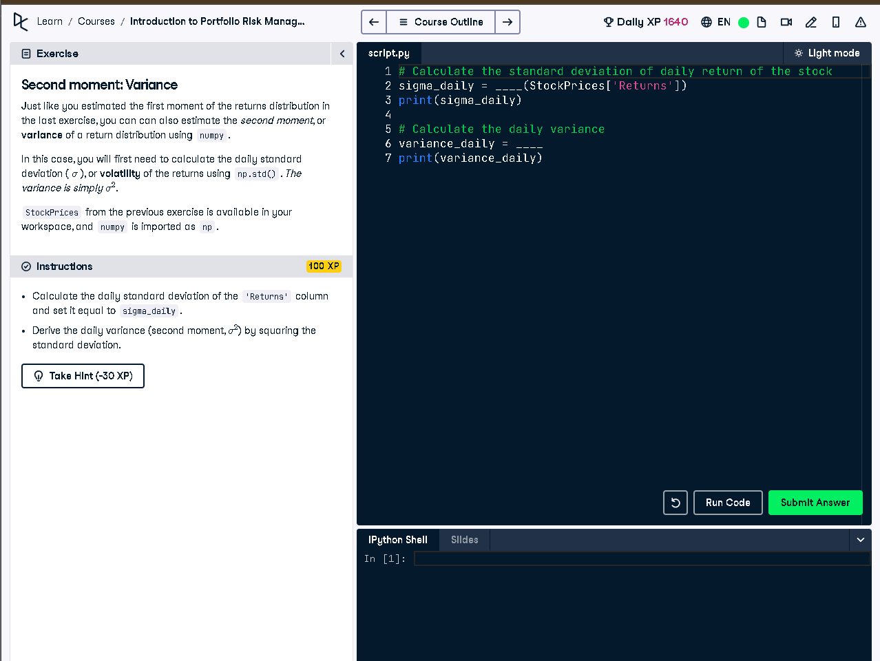

Python Code
# Calculate the standard deviation of daily return of the stock
sigma_daily = np.std(StockPrices['Returns'])
print(sigma_daily)
# Calculate the daily variance
variance_daily = sigma_daily ** 2
print(variance_daily)

Explanation
We calculate how much the daily stock returns change using standard deviation (sigma_daily). Then we square this value to get the daily variance (variance_daily), which measures how spread out the returns are around the average. High variance means more risk.

